Chapter 18, Solution 13.

- We know that 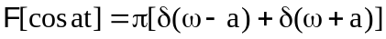.

Using the time shifting property,

(b)

g(t) = -u(t+1) sin (t+1)

Let x(t) = u(t)sin t, then 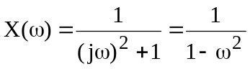
Using the time shifting property,

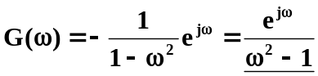

(c ) Let y(t) = 1 + Asin at, then

h(t) = y(t) cos bt

Using the modulation property,

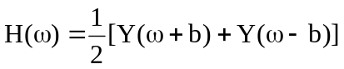

(d) 